**

*2c Stable steady states for for toggle switch. It can be reproduced qualitatively. At higher values it is observed that the curve obtains a constant value at around 5 units*

**

*2c. BONUS Stable and unstable steady states for for toggle switch. It can be reproduced qualitatively. At higher values it is observed that the curve obtains a constant value at around 5 units. The points near S=1.25 indicate bistability as two steady states are obtained as depicted by the presence of multiple points at similar values of S.*

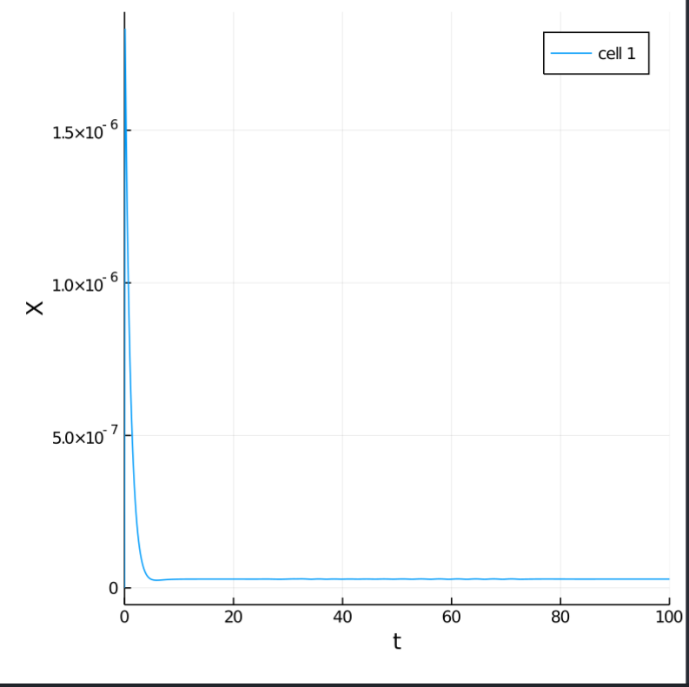 2d X vs t at S=0.02 .

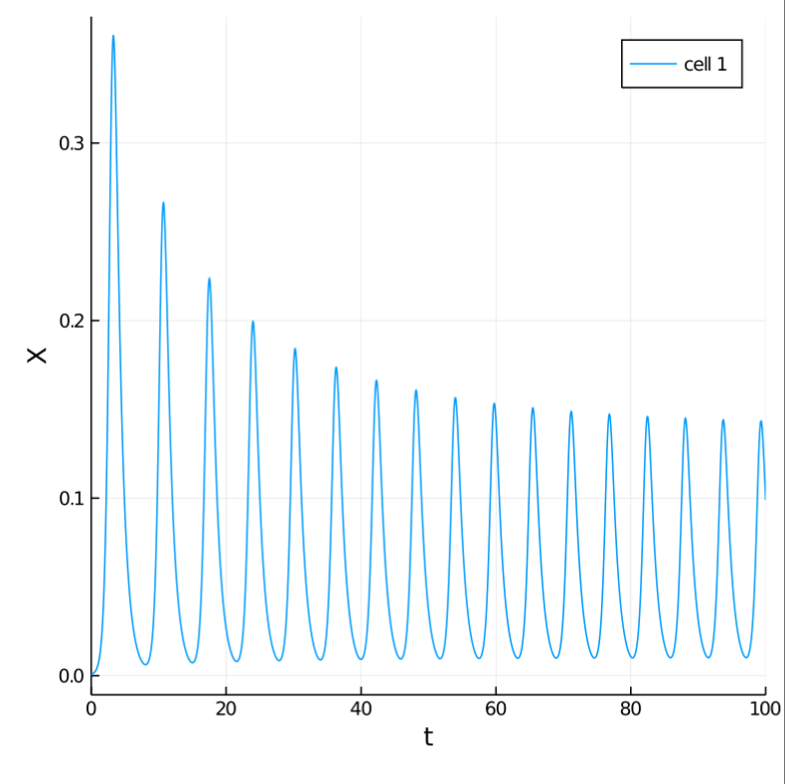 2d X vs t at S=100

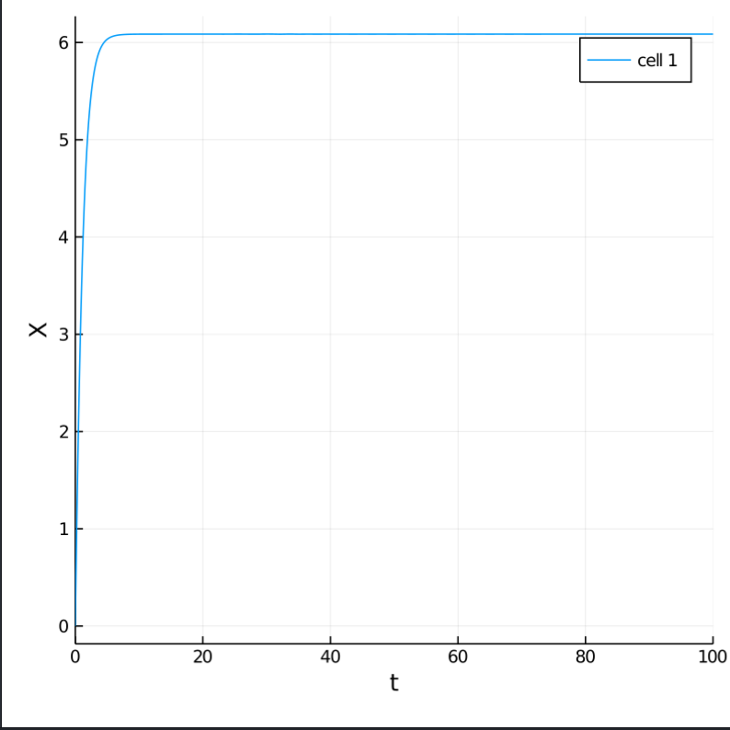 2d X vs t at S=10e5

The data from the paper is reproducible.

*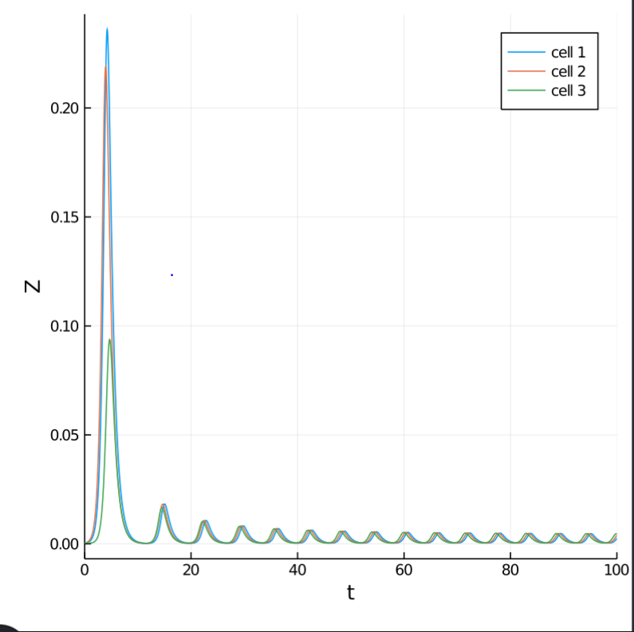*

*2e Coherent oscillations when steady state value above saddle bifurcation is taken as the initial condition and S is changed to 100*

*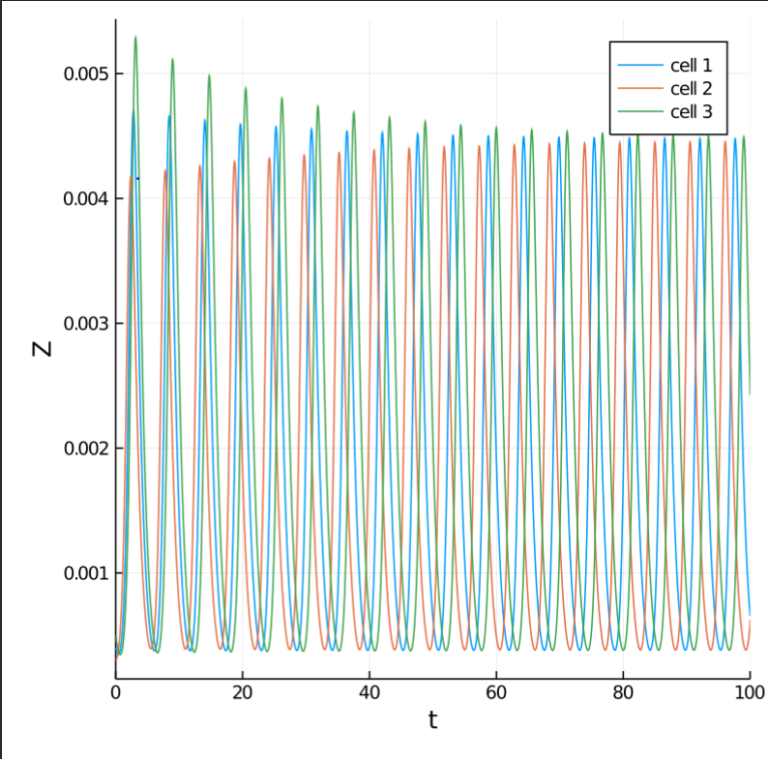*

*2e Incoherent oscillations when steady state value below hopf is taken as the initial condition and S is changed to 100*

*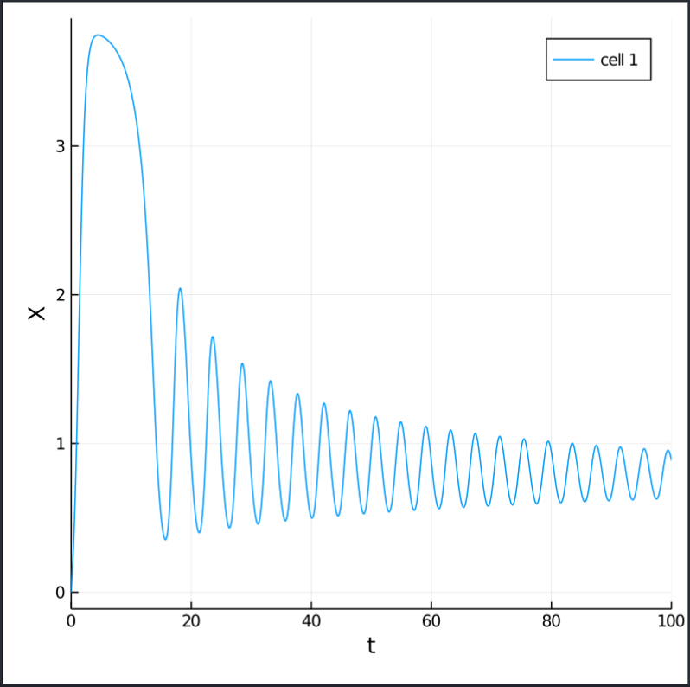*

*2e Stable oscillations near the saddle node bifurcation point*

*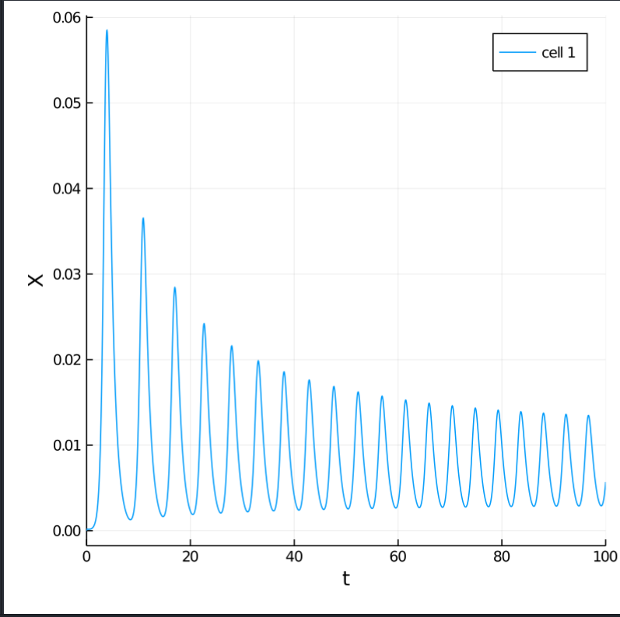*

*2e Unstable oscillations near the hopf bifurcation point*

*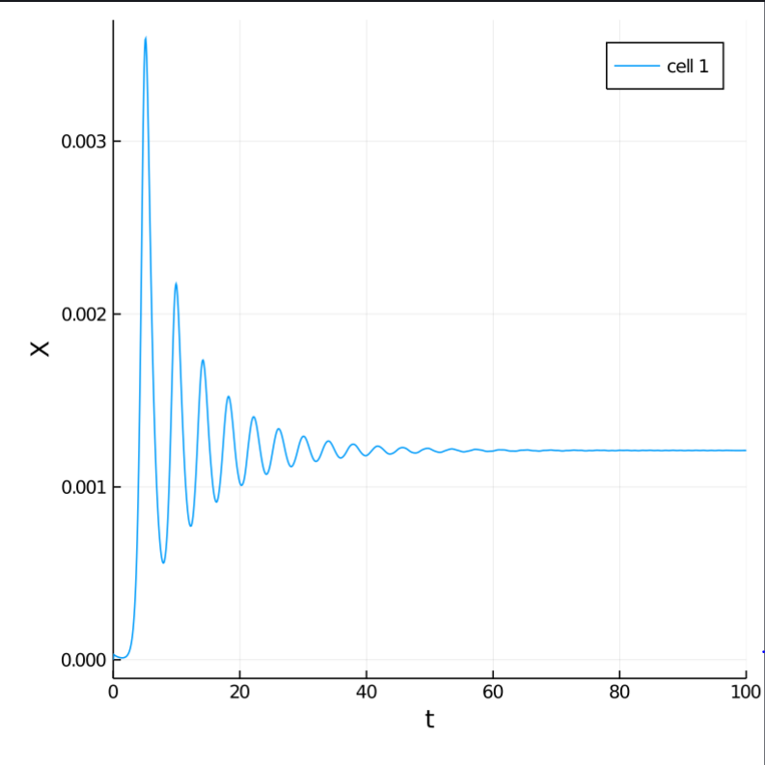 Steady value of x obtained at S=0.4*

*Steady value of x obtained at S=35500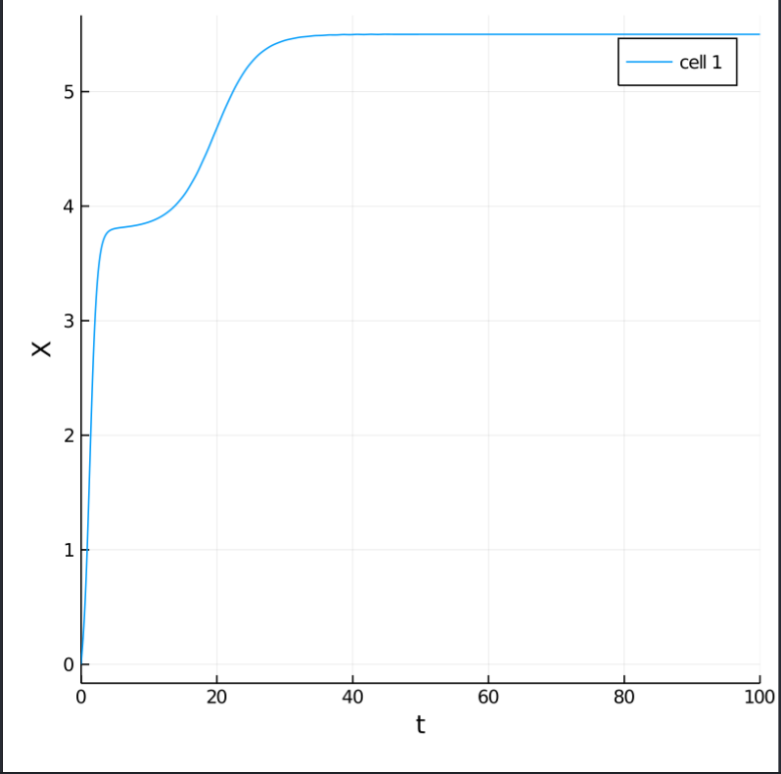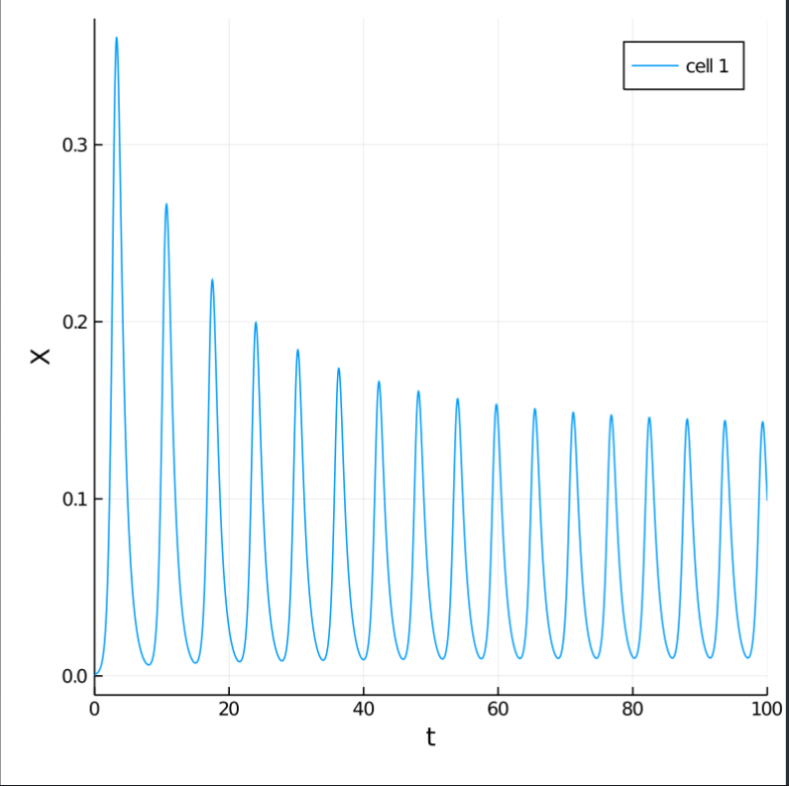Oscillations with varying amplitude at S=100 for given parameters in table S.1*

*Os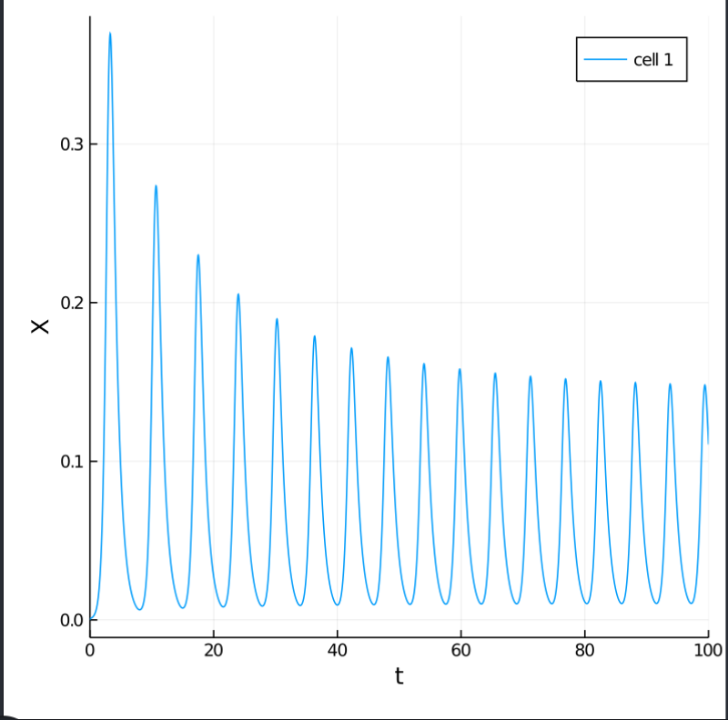*

*Oscillations with varying amplitude at S=105 for given parameters in table S.1*

*1d Predicted curve vs experimental curve n=1.5 W1=0.26 W2=190 K=0.24mM. The grey curve is for the in vivo value of RNAP concentration. It is observed to fit the experimental in vitro curves the RNAP concentration needs to be increased from 30nM to 126nM which indicates that more RNAP is added in in vitro experiments than that present in the cell.*